Demo3 Book Store

devops solution implementation document

Version 0.1

For

iSmartBook Corp.

Contents

1 Introduction 4

1.1 Purpose 4

1.2 Definitions 4

1.3 References 4

2 Background 5

2.1 System Overview 5

2.2 Business Case 5

2.2.1 Business Goals 5

2.2.2 Major Features 5

2.3 Business Constrains 6

2.4 Service Level Agreement 6

2.4.1 Scope and Applicability 6

2.4.2 Service Quality Guarantees 6

3 Technology stack Description 7

3.1 Environment Diagram 8

3.1.1 Representation 8

3.1.2 Element Catalog 8

3.2 Deployment Diagram 9

3.2.1 Representation 9

3.2.2 Element Catalog 9

4 Risk Analysis 10

5 Appendix A – References 11

Revision History

|  |  |  |  |
| --- | --- | --- | --- |
| Date | Version | Section | Author |
|  |  |  |  |
|  |  |  |  |
|  |  |  |  |
|  |  |  |  |

# Introduction

## Purpose

The Main Goal is to prepare fully automated solution to deploy ASP.NET MVC application to the MS Azure. As a CI service Azure DevOps should be used. As a PaaS cloud provider MS Azure AppServices should be used.

Anticipated Outcomes:

* Achieve book entry time 15 min per 1 book
* Achieve expenses threshold $2K per month for the 1st quarter counting from project start date.
* Anticipated load is 1000 users/min and 5000 users
* There is 4 envs: development, testing, staging and production
* CI process is fully automated

## Definitions

The Definitions section lists the acronyms and terms used in this document which might possess lesser familiarity or double meaning to the reader.

|  |  |  |
| --- | --- | --- |
| # | Term | Definition |
|  | CI | Continuous Integration |
|  | MVP | Model-View-Presenter |
|  | PaaS | Platform as a Service |
|  | SLA | Service Level Agreement |

## References

The References section provides a complete list of all the documents referenced elsewhere in this document.

|  |  |  |  |  |
| --- | --- | --- | --- | --- |
| # | Version | Date | Document Name | Published by |
|  |  |  |  |  |
|  |  |  |  |  |
|  |  |  |  |  |
|  |  |  |  |  |

# Background

## System Overview

iSmartBook Corp. is a small company. As its primary business is to develop and support word wide online book store including web site and mobile application.

The company was established in 2015 as a small portal for users who likes to read books and share their expressions. Currently it has grown globally and run their own online book store in the US. Company has plans to expand their services globally in the Europe and Asia as well.

The intent of this project is to developing cloud based online book store.

## Business Case

The intent of this project is to developing cloud based online book store:

* Data managers should be able to add book entry via admin panel including book file, basic information about the book: author, year, description. Preferable way to keep books is secure blob storage.
* Customers should be able to view general book information and also add chosen book to the Cart.
* Preferable stack is ASP.NET MVC , MS SQL and Azure Cloud.

### Business Goals

The section enumerates essential business goals for the solution.

|  |  |
| --- | --- |
| # | Description |
|  | MVP of Online book store should be delivered in 3 month |
|  | Support online access for customers and data managers |
|  | Implement DevOps best practices |
|  | Optimize expenses for the 1st quarter of running MVP solution to $2K per month |

### Major Features

The section enumerates solution major features.

|  |  |
| --- | --- |
| # | Description |
|  | Centralized transaction data storage and management on the cloud |
|  | Access from the mobile devices and desktop browsers without loss of quality in user experience |
|  | Service uptime not less than 99.9% |

## Business Constrains

The section lists the constraints that provided the significant influence over the architecture accounted for in the designed solution. These can be of business, technical, resource, and other types.

|  |  |
| --- | --- |
| # | Description |
|  | The company puts a limited budget toward building the solution assuming up to 5 people total participating in the solution implementation and deployment. |
|  | To reach the company's business objectives the first version of the solution is expected to be built within 3 months from the start of implementation. |
|  | Online book store users should have secure access to the web interface |

## Service Level Agreement

The SLA section provides key parts of the Service Level Agreement applicable to the designed solution be supported by the proposed solution architecture.

### Scope and Applicability

This Service Level Agreement (“SLA”) establishes the service quality parameters that are to be applied to the use of Demo3 Book Store services, and is part of the Demo3 Book Store Services Customer Agreement.

The terms and conditions specified in this agreement apply solely to the services provided as callable API hosted by the company, herein called “Covered Services.” This SLA applies separately to each service consumer (“Consumer”) that is using the Covered Services. iSmartBook Corp. reserves the right to change the terms of this SLA in accordance with the Demo3 Book Store Services Customer Agreement at any time.

### Service Quality Guarantees

The Covered Services will be operational and available to Consumers at least 99.95% of the time in any calendar month. If iSmartBook Corp. does not meet this SLA requirement while the Consumer succeeds in meeting its SLA obligations, the Consumer will be eligible to receive Financial Credits as compensation. This SLA states the Consumer’s exclusive right to compensation for any failure on iSmartBook Corp.’s part to fulfill the SLA requirements.

# Technology stack Description

**Development tools:**

* MS Visual Studio 2017
* ASP.NET Core MVC Framework
* Entity Framework Core 2.1.1

**CI/CD service :**

* Azure DevOps Pipelines

**Deployment service :**

* Azure AppServices;
* Azure SQL
* Azure Insights

## Environment Diagram

### Representation

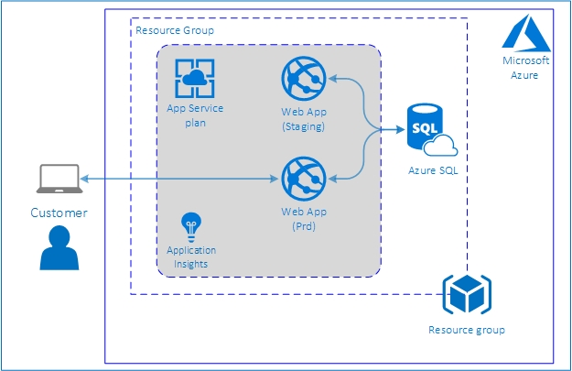

### Element Catalog

Table of annotated elements

|  |  |
| --- | --- |
| Name | Description |
| Aplication Insights | Azure Cloud service for monitoring web application in AppServices |
| Azure SQL | Instance of SQL server (for staging and production) with application database |
| Customer | User, connected to the application site via browser |
| Rsource group | Deployment and management Azure service for access control, auditing, and tagging features to secure and organize your resources after deployment |
| Web App (Staging) | Web application deployed on Azure AppServices for test |
| Web App (Prd) | Web application deployed on Azure AppServices in production |

## Deployment Diagram

### Representation

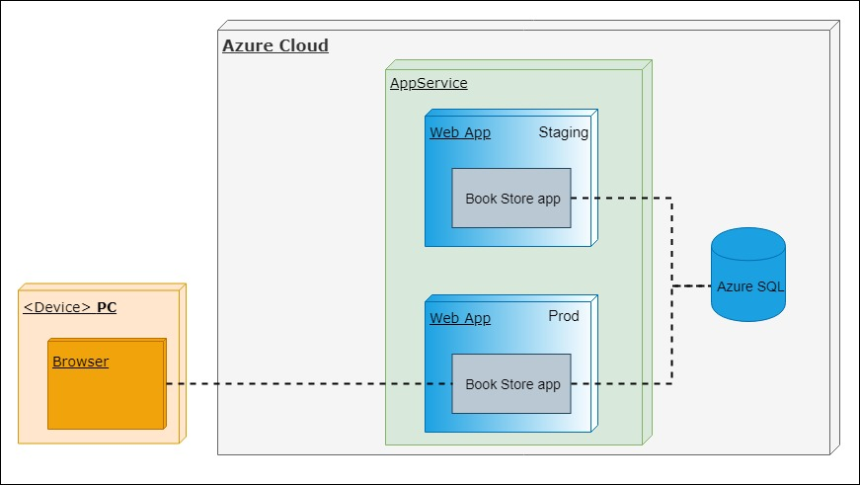

### Element Catalog

Table of annotated elements

|  |  |
| --- | --- |
| Name | Description |
| Azure SQL | Instance of SQL server (for staging and production) with application database |
| Book Store app | Artifact of web aplication |
| Web App (Staging) | Web application deployed on Azure AppServices for test |
| Web App (Prod) | Web application deployed on Azure AppServices in production |

# Risk Analysis

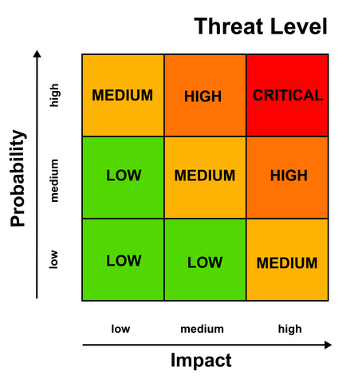

|  |  |  |  |
| --- | --- | --- | --- |
| Impact | Probability | Level | Description |
| High | Low | Medium | Azure Cloud region failure |
| High | Low | Medium | One of Azure Cloud services (Azure AppServices, Azure SQL etc.) failure |
|  |  |  |  |
|  |  |  |  |
|  |  |  |  |

# Appendix A – References

* Project’s repository: <https://github.com/vitalidn/DP157.Team1.Demo3>
* Web application site: [https://minimoobookstore.azurewebsites.net](https://minimoobookstore.azurewebsites.net/)